**ABOUT US**

Transafty is an online logistics platform offering transport solutions to transporters, drivers, shippers, freight forwarders, and other stakeholders in the logistics industry.

Our experienced professional team solves the industry's biggest problems using the best technology available in order to promote your connections with carriers.

Our objective is to make the transport process simpler, faster, and more efficient by:

Providing better vehicles,

At more affordable rates,

Ensuring safety of your shipments, and

Ensuring deliveries are timely.

We bring on board our wealth of experience and knowledge in this industry and global best practices to help you scale your logistics needs cost effectively.

We have a strong network of vehicles all over Nigeria, and deploy the latest technology to seamlessly connect and communicate with our wide network of truck operators to provide you with the most reliable and effective trucking services.

Our customer support service is ready to serve you with utmost professionalism, round-the-clock with any enquiry, complaints, comments or difficulties you may have. We are committed to achieving the highest level of customer satisfaction.

We also continuously strive to help keep prices competitive, so that our customers get the best deal in every booking they make on our platform, as this could contribute in no small measure to their profitability.

Now, you can be rest assured that the days of all the hassles you experienced with transportation of your important consignment and the related logistics services are over!

Get in touch with us today and experience a premium, hassle free truck booking experience.

**HELP**

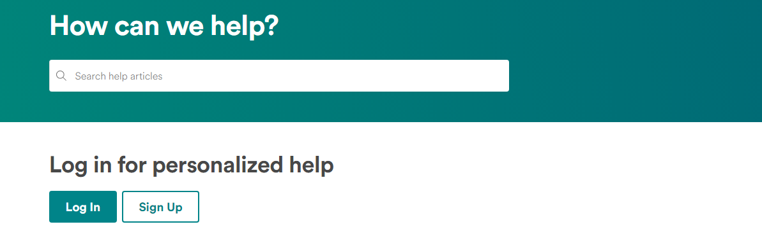

**ABOUT TRANSAFTY**

**What is Transafty?**

Transafty is NIgeria’s premium truck booking platform for connecting individuals and companies looking for haulage services and construction equipment with top-quality, verified logistics service professionals.

**How does it work?**

**For Shippers:**

We have simplified the process into 3 simple steps

-Enter your truck/load information and click the submit button

These details are sent to our network of transporters and when a match is made, you will be notified via email

-The amount is invoiced to you. After payment is received, the booking will be confirmed

- Receive vendor details and updates through email notifications

**For Transporters:**

**Find loads using load search**

Start your load search by inputting your trip starting point, final destination, and your equipment type; and the database will execute your search and display truck loads that match your request and select the loads you prefer

**Create load alerts to receive real-time notifications**

Inform shippers about the equipment type you have available for hauling freight, where you are hauling from and which lane route you prefer to run.

**Find backhauls**

Never worry about deadheading again by searching through loads found on Transafty’s freight matching network. Just indicate in your Dashboard app settings that you are empty or available and we will show and send you available loads.

**Why Choose Us**

We use the latest technological tools in the logistics industry to make your operations simplified and more efficient. Our aim to make your processes faster, easier and cheaper, thereby saving you time, reducing your costs and improving your profits

**Who Can Use Transafty**

Our platform is built to be used by all stakeholders in the logistics industry including: truck owners, shippers, freight forwarders, and so on.

**How does Transafty Benefit me?**

**To Shippers:**

-Access to verified trucks and truck companies

-Simplified booking processes

-Get updates on available trucks

-See feedback and rating of companies before engaging them and leave feedback and rating on your experiences as well

**To Transporters:**

-Access to real time load and load opportunities

-Notifications on backloads

-Feedback and Ratings gives you an objective way of reviewing your drivers and systems

-Average industry prices helps you prevent under-pricing your services

**-BOOKING**

[**How many days or hours in advance I need to place a booking?**](https://www.trukky.com/faq#collapseOne)

Currently we accept same day booking or up to 2 days in advance. However, bookings are subject to availability of trucks

[**How would I know my approximate trip distance and my approximate bill amount?**](https://www.trukky.com/faq#1)

Your approximate bill amount will be notified to you during your booking process

[**If I received confirmed booking ID, is there any chance of no show-off of the truck?**](https://www.trukky.com/faq#2)

We are dedicated to service all confirm bookings. In case we are unable to service you due to certain unforeseen circumstances, you will be duly notified as soon as possible.

[**How to cancel a booking?**](https://www.trukky.com/faq#3)

Currently you would need to raise a cancellation request through web/Phone at least 60 minutes prior pick up time

[**What are the different modes of payment you support?**](https://www.trukky.com/faq#4)

Currently we have the following modes of Payment:

-Bank transfer/Deposit (please send payment teller to [payments@transafty.com](mailto:payments@transafty.com))

-Online payment

Note: Booking will only be confirmed after 100% of invoiced amount has been received. Certain contractual transactions are however exempted

[**How will I receive the bills?**](https://www.trukky.com/faq#5)

Bills will be delivered via E-mail.

[**Would I get any manpower for loading /unloading & packing service?**](https://www.trukky.com/faq#6)

All services confirmed through Transafty only includes transportation of goods and for any manpower help you need to co-ordinate with assigned operator/driver.

**-LOAD AND TRUCK POSTING**

**Steps for Posting Trucks**

* Log in
* Username – Email address
* Password – Created Password
* Forgot Password – Click “Forgot Password” to reset password
* Select Post
* Trucks (click on)
* 9 items are required:
* Vehicle number/ID, Driver’s name, Driver’s mobile number, Service type-use drop down menu(local, inter-state, Both), Origin (select or type in load origin; country – defaults to Nigeria) Destination (select or type in load destination; country – defaults to Nigeria), Truck Type – use drop down menu, Scheduled Date – use calendar, Shipping Company (1st/2nd Gate)-To be typed in
* Click on Submit
* May be deleted
* May be edited here before reposting

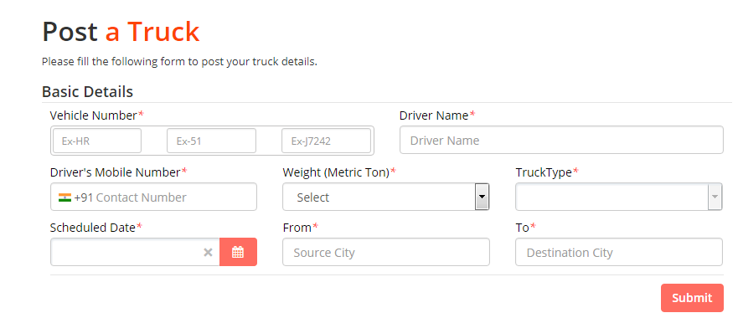

**Steps for Posting Loads**

* Log in
* Username – Email address
* Password – Created Password
* Forgot Password – Click “Forgot Password” to reset password
* Select Post
* Loads (click on)
* Fill in the form
* 8 items are required:
* Origin (select or type in load origin; country – defaults to Nigeria) Destination (select or type in load destination; country – defaults to Nigeria) ,Truck Type – use drop down menu, Number of trucks-use drop down menu, Schedule Date – use calendar, Material-use drop down menu, Weight- use drop down menu or type in, Shipping Company (1st/2nd Gate)-To be typed in
* Click on Submit
* May be deleted
* May be edited here before reposting

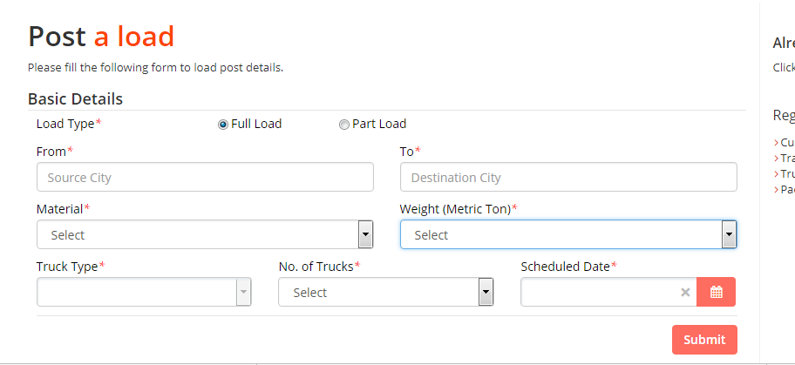

**-SHIPMENT**

**How Can I Be Alerted When Shipment Deliveries Posted?**

We send out delivery notifications to partners both for forward and reverse logistics via email once a shipment delivery has been created. You can also enable Notification Preferences so you get alerted when a delivery has been created that you might be interested in hauling. These alerts can be based on your current location, your truck and cargo type you haul.

**How do I know the item I am delivering is safe to carry?**

Our terms of service prohibit sending illegal or contraband items being delivered by shippers via our platform. If you suspect, any illicit or prohibited item, please contact support for help via support@transafty.com

**What Kind of Auto Insurance Do I Need?**

A Transafty partner should have a current comprehensive auto insurance policy. Transafty partners are responsible for all claims and necessary contacts with their insurance carrier in the event of a motor vehicle accident or other liability claim on their vehicle.

While some hauling contract would stipulate that a transporter obtain GIT (Goods in Transit) insurance policy, as a requirement to haul their shipment, we advise shipper to obtain a GIT policy for their shipment. We can help arrange such insurance but shippers responsible for all claims and necessary contacts with their insurer in the event of a liability claim on their shipment.

**Can I Ask For More Money On a service?**

Transafty gives you the liberty to make an offer you are comfortable with, and come to an agreement with the shipper. This means that the payment for a service is based on a satisfactory price between both parties. We know that some partners may sometimes desire a bit more of a payout for a service, but asking for more on a service is discouraged.

Shippers are also given an opportunity (on the app) to add a little extra to a service delivery as a reward if they so choose, but they’re not expected to pay anything outside of the amount agreed with a delivery partner.

Delivery partners who regularly follow the standard process are usually chosen over someone who requests a higher payout for the service. If a Partner repeatedly asks for more money on haulage services, their account will be considered for suspension.

Keep in mind that if a service doesn’t seem worth it based on the shipment destinations or price points, you are totally free to pass on it and wait for the next one that fits your requirements. Transafty booking platform is very flexible as partners aren’t required to take a certain number or percentage of service deliveries, so feel free to just wait for the right service that fits you.

**What Do I Do If a Shipper Is Unresponsive To My Offer Or Comment?**

If you have put an offer on a haulage service or equipment booking but the shipper is not responding, you are able to cancel your offer within the Transafty app so you can get on with your itinery. We know that your schedule is just as important as the shipper’s, so there’s no penalty for rescinding your offer on a service before it’s been accepted.

**What Do I Do If I'm No Longer Able to Deliver a Delivery That I've Been Accepted for?**

We know the unexpected situations can come up sometimes. If you can't fulfil a service or run into a problem during a shipment delivery, just call support on 08131668024, or click the TransaftyAssist™/ Get Help button in your app and one of our Support Team members will arrange for another partner to complete your delivery. However, do communicate this on time so as to give enough time to arrange a different delivery partner and ensure that our senders do not get disappointed with their delivery requests.

**What Do I Do If I Can’t Reach the Recipient When I Am at The Delivery Location?**

If you arrive at the delivery location and you’re unable to reach the recipient, you should contact Transafty Support on 08131668024 team to get help.

**Can I Deliver Multiple Shipment Deliveries at The Same Time?**

Yes, it's completely up to you whether you handle a single Delivery or multiple Deliveries at the same time. Before offering to handle multiple shipment deliveries at the same time, be 100% sure that your trucks are available and in good working condition; that you'll be able to meet each delivery deadline, and that you can handle the pick-up and drop-off logistics associated with each Delivery.

**Is There Anything I Can't Ship/Haul Through Transafty**

Prohibited items include:

• Anything illegal

• People

• Tobacco or alcoholic beverages

• Firearms or weapons

• Fireworks

• Hazardous Waste

• Sick, injured or aggressive animals

• Medicine for a person other than the purchaser or prescription-holder

• Currency, postage stamps or money orders

• Cremated remains, human remains, human body parts, etc.

For a complete list of prohibited items, please see our Terms of Service at www.Transafty.com/terms.

**How Do I Track a Delivery?**

*This feature is not yet available. We are working on making it available for our users as soon as possible.*

As a Shipper or a Transporter on Transafty platform, you can always track the real-time status of an active shipment. Just click on the tracking link that was emailed or texted to you, or visit https://www.track.Transafty.com and enter the tracking number that was provided to you.

**What If I Have a Question, Dispute Or Other Problem During A Delivery?**

Should your Delivery hit a bump in the road, or you sense a distress, please call our support line +2348131668024 which connects you to our Transafty support. If you have less urgent questions or need help before or after a shipment is made, you can email us at support@transafty.com, and a support team member will respond as quickly as possible.

**-CUSTOMER SERVICE**

**How do I contact customer care for enquiries, suggestions and/or complaints?**

Our customer care helplines are available 24/7. You may reach us via the customer helplines displayed on the homepage, email us, or use the chat option on the homepage. A customer representative will be on hand to help you with your requirements. However, if you are unable to reach our customer care representative, kindly leave a message on any of the aforementioned helplines, and we will contact you as soon as possible.

**-REGISTRATION**

**How Can I Be A Transafty Transporter?**

It’s very easy. Once you've signed up, you can apply to be a Transafty transporter. The onboarding process involves a sign up on our platform, completion of profile and documents validation. To get started, visit transafty.com and sign up— the entire application takes minutes and you can be making shipments as soon as the process is completed.

**What Do I Need To Be A TransaftyTransporter Partner?**

To be a Verified Transafty partner, you must be

- 18 years or older

-Have a truck or be the manager of a truck,

-Provide a valid government issued ID Card and Utility bill for individuals

* Student ID Cards and NYSC ID’s are also acceptable,

-Provide CAC registration number and utility bill for a registered business

-Having a smart phone is highly recommended

**How Much Does Registration on Transafty Cost?**

It's completely free to join the Transafty platform.

**How Can I Register on Transafty**

You can register by clicking on the “Sign in” botton on the top right hand corner of the home page, and filling up the information required. Upon completion, click “Submit”. The final step would require you to verify your email or phone number.

If you have any difficulty registering, please use our helplines and we would be happy to help you out.

**I am not able to register on Transafty myself. How can you help me**

If you are unable to do the registration yourself, you can call our helplines and we would help you to fill-out your details. However, we would advise you to get someone to readout and interpret the terms of agreement to you before completing registration

**I didn’t receive account confirmation email**

Please ensure that the email you supplied is correct and active. Also check your spam box, as emails could be delivered there sometimes. If you need further help, please reach out to our customer service via the helplines

**I don’t remember my password**

Click on the “Sign in” tab. On the panel, locate “Forgot your password” link and click on it. Enter your registered email address/phone number when prompted and click send. Check your mailbox and find the password reset link. Click on the link to reset your password.

**How do I change my Password?**

Sign in into your account and go to your dashboard. click on “Change Password”. You will be directed to a page. Enter your old password and the new password you have chosen. Retype the new password and click “Submit”

**How do I edit my account information?**

Sing in and go to your dashboard. Click on “Edit Profile” and change/modify the information you wih to. Then click submit

**I didn’t receive Verification email**

Please contact customer service.

**-MY ACCOUNT**

**How Can I Register on Transafty**

You can register by clicking on the “Sign in” tab on the top right hand corner of the home page, and filling up the information required. If you have any difficulty registering, please use our helplines and we would be happy to help you out.

**How do I login into my account**

Click on Sign in” on the top right hand corner of the home page and enter your registered email/phone number and your password. Then click on “Sign in”

**-PAYMENT**

**How to make Payment**

We have secure payment options available on our platform. Follow these instructions to get to the booking and payment page.

Select the truck of your choice and

Click the "Book Now" Button to make a booking

Fill in the required information.

After filling in the required information, go the section "Make Payment" to select a payment option.

On selecting this option, a tabbed box would be revealed below the selection, where you would find various options for payment.

Select one of the options to reveal various options of payment.

Follow the instructions in the box for the selected option to Proceed to their respective payment portals.

Option 1: Card Payment

You may make payment online using your debit or credit card using any of the following payment gateways

Paystack: You may use your Naira MasterCard, VISA or Verve cards to pay for your invoice. On this payment gateway you only need to enter your card details for the first successful transaction. You may click here to learn more about this.

PayPal: PayPal accepts most foreign denominated credit or debit cards. You may use PayPal to process MasterCard, Discover, American Express, Diners, JCB, PIN debit cards with the Visa or MasterCard logo.

To get started, simply visit to access your invoice and choose any of the payment gateways.

Option 2: Bank Payment

You may make your payments to:

Account Name: D.R. MATT INTERNATIONAL SERVICES LIMITED

Account No: 1019117910

Bank: UNITED BANK FOR AFRICA (UBA)

OR

Account Name: D.R. MATT INTERNATIONAL SERVICES LIMITED

Account No: 0173206136

Bank: Guaranty Trust Bank (GTB)

OR

Account Name: D.R. MATT INTERNATIONAL SERVICES LIMITED

Account No: 0065901055

Bank: Diamond Bank Plc

NB

Once you have made payment, send the details of your payment such as depositor's name, slip number, date of payment, amount paid and what you paid for or the invoice number for the funds to [support@transafty.com](mailto:support@transafty.com)

**How and When Do I Get Paid?**

Transafty partners are paid via direct deposit into their bank account. Each direct payment should appear in your designated bank account within 24-48 business hours of delivery completion, unless the delivery contract stipulates otherwise. The amount earned can be viewed at all times in the partners’ dashboard. A partner can also choose to leave or withdraw his earned income from his dashboard at any time after the payment period stated above.

**How Much Will I Get Paid?**

Transafty partner set the fees for completing the delivery of a shipment. The partner sets a budget for which the delivery is to be made, the shipper then accepts the fees or makes an offer until a fee is agreed between the two parties. The partner gets paid the total amount of the fee agreed for the service minus the total commission deducted by Transafty.

**-TECHNICAL SUPPORT**

**[What are the recommended internet browsers to use for Transafty](https://truckstop.com/support/" \l "collapse6)**

Transafty.com works with all popular web browsers. Google Chrome and Mozilla Firefox are the recommended Internet Browsers to use. For best experience when using Transafty.com, we recommend that you upgrade to and use the latest browser versions. This will also make browsing faster and safer for you.

**Do you use cookies?**

Cookies are pieces of information that gets stored on a computer’s hardware when a website is visited.

Transafty.com uses cookies to enable the browser track the information provided to us by a user. Cookies do not contain viruses and are utilized for security and customization purposes.

**[What are the recommended specifications for internet speed and computer hardware to have an optimal experience using Truckstop.com?](https://truckstop.com/support/" \l "collapse7)**

1. Minimum Internet Speeds  
a. 1mbps Download Speed  
b. 1mbps Upload Speed  
2. Recommended Internet Speeds  
a. 5mbps Download Speed  
b. 5mbps Upload Speed  
3. Recommended Computer Hardware  
a. Processor:  
i. Intel or AMD Dual Core 2.5ghz  
b. Memory (RAM)  
i. 4 GB  
c. Hard Drive Space Free  
i. 5GB

**-TERMS OF SERVICE & PRIVACY**

**See “Terms of Service” and “Privacy Policy” sections**

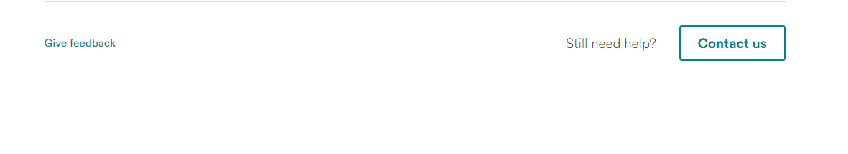

-FEATURE REQUEST

# **How To Submit A Feature Request**

Something missing in our app? Have an idea on how we can make the Transafty experience better? Post it in the ["Request Feature"](https://support.roadie.com/hc/en-us) section of this site or send us an email to feedback@transafty.com and let us know what you're thinking about.